
SECRET
FUNCTION INTRODUCTION
Function management
Function Name: |  | Hill Descent Control
Function Mapping: |  | Driver assistance, autonomous driving, and chassis management
Function: |  |  |  | Function-ID:
 | Name |  | Roler | Date | signature
Create/Modify:
check:
Approve OMK:

1 Function Introduction 3
1.1 Function description 3
1.2 Function partner list 3
1.3 Function action mode diagram 4
2 System Architecture 4
2.1 Function architecture 4
2.2 Sub-function list 5
2.3 Description of function interface 5
3 Basis function specification 6
3.1 Description of the function status 6
3.2 Logical signals of function 7
3.3 Base Parameters of function 8
3.4 State interpretation and diagram 9
3.5 Diagnostic requirements 9
4 Major Additional Function 10
5 Special States Detect 10
6 Functional safety 10
6.1 Hazard and Risk analysis 10
6.2 Functional safety concept 10
7 Regulatory Requirements 11
8 Function Dependencies 11
8.1 Internal 11
8.2 Extra 11
9 Special Performance Requirements 12
10 Appendix A 12
10.1 Change History 12

Function Introduction

Function description
HDC (Hill Descent Control) autonomously controls the brake torques to maintain a customer set target speed. The feature is commonly referred to as Hill Descent Control by a majority of OEMs. When the feature is actively controlling, the driver has the ability to override the HDC feature with the use of the brake or accelerator pedal and the transitions should be seamless to the driver.
At the vehicle level, this feature is a low speed (steep) downhill cruise control feature typically intended for use on unmaintained surfaces (off-road).


Figure1. Hill Descent Control Demonstration

Function partner list
- iBRS
- Wheel Speed Sensor
- IMU
- LDCU
- HMI

Function action mode diagram
The function 'Hill Descent Control' calculates a request for the hydraulic brake system to build up hydraulic brake force to decelerate the vehicle when function has been activated by the driver.
The diagrams are based on ZF IBC (Integrated Brake Controller) system.
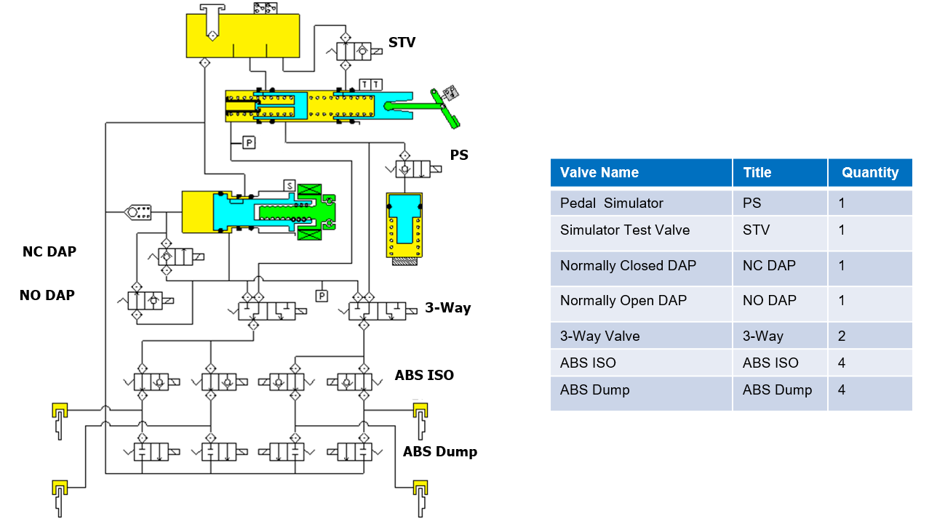
Figure2. Hydraulic Schematic

System Architecture

Function architecture
The HDC function is integrated in the braking product, receiving information from the four wheel speed sensors, HMI, and IMU, and calculating and outputting the target pressure at the four wheel ends.
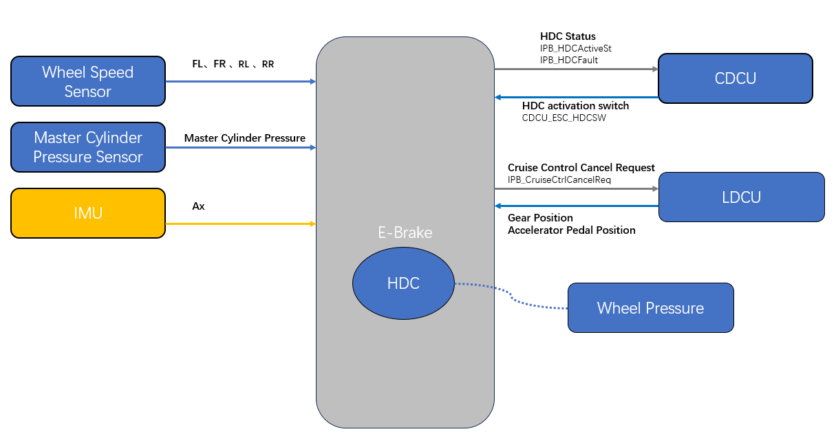
Figure 5. HDC system architecture

Sub-function list
N/A

Description of function interface

System dependency (Signals Interaction)
The following table lists the interactive signals for HDC function. The names in the table are from VW CMP21D CEA Comms matrix “IBRS_CEA2_CAN_MATRIX”.
Signal Name | Sender | Tx/Rx | Cycle | Unit | Range | ASIL Level | Description
LDCU_EVSysReadySt | LDCU | Rx | 10ms | Enum | 0x0:Not ready;  0x1:High Voltage On;  0x2:Ready; | ASIL B | The state of vehicle
LDCU_CurrentGearLev | LDCU | Rx | 10ms | Enum | 0x0:Invalid;  0x1:D;  0x2:N;  0x3:R;  0x4:P;  0x5-0x7:Reserved | ASIL B | The Current Gear
LDCU_AccPedalSig | LDCU | Rx | 10ms | % | 0-100 | ASIL C | Accelerator pedal position signal
LDCU_AccPedalSigVD | LDCU | Rx | 10ms | Boolean | 0-1 | ASIL C | The valid of accelerator pedal position signal
CDCU_ESC_HDCSW | CDCU | Rx | 100ms | Enum | 0x0:No command  0x1:On  0x2:Off  0x3:Reserved | ASIL C | HDC SW switch
CDCU_ESC_PATASw | CDCU | Rx | 100ms | Enum | 0x0:No command;  0x1:Normal;  0x2:Sport;  0x3:Off; | QM | ESC_OFF SW
LongAcceleration | IMU | Rx(Private) | 10ms | g | -2~2 | ASIL B (D) | Longitudinal Acceleration
LongAccelerationValid | IMU | Rx(Private) | 10ms | Enum | 0x0:valid  0x1:invalid  0x2:reserved  0x3:initialization | ASIL B (D) | The valid of longitudinal acceleration
IPB_HDCFault | iBRS | Tx | 20ms | Enum | 0x0:Not fault;  0x1:fault | ASIL B | HDC fault state
IPB_HDCActiveSt | iBRS | Tx | 20ms | Enum | 0x0:Not Active;  0x1:standby  0x2:Active;  0x3:reserved | ASIL B | HDC activation status
IPB_CruiseCtrlCancelReq | iBRS | Tx | 10ms | Enum | 0x0:No request;  0x1:Request; | ASIL B | ESP request LDCU to cancel cruise control
IPB_BrkLightOnReq | iBRS | Tx | 20ms | Boolean | 0-1 | ASIL B | Brake Light On Request

Hardware Interface
Name | Type
KL15 | Hardwired
KL30 | Hardwired
Left front wheel speed sensor | intelligent
Right front wheel speed sensor | intelligent
Left rear wheel speed sensor | intelligent
Right rear wheel speed sensor | intelligent
Master Cylinder Pressure sensor | intelligent
IPB CAN(H、L) | Hardwired

Basis function specification

Description of the function status
The HDC function activate when the vehicle is on the downhill and the driver activate the function via HMI, then the driver can release the brake and let the HDC function to control the deceleration during downhill, while the driver can adjust the HDC target speed by pressing brake pedal or accelerator pedal.
The fig.6 introduce the typical HDC working process:
a. HDC SW switch on HDC status will transit from No Active to standby
b. In case of activation condition fulfilled, HDC will transit from standby to Active
c. In case of activation conditions not fulfilled, HDC will transit from Active to standby
d. In case of vehicle speed below HDC target speed, HDC will transit from Active to standby
e. In case of brake disc overheat, HDC will transit from Active to No active
f. In case of HDC SW switch off, HDC will transit from Active to No active
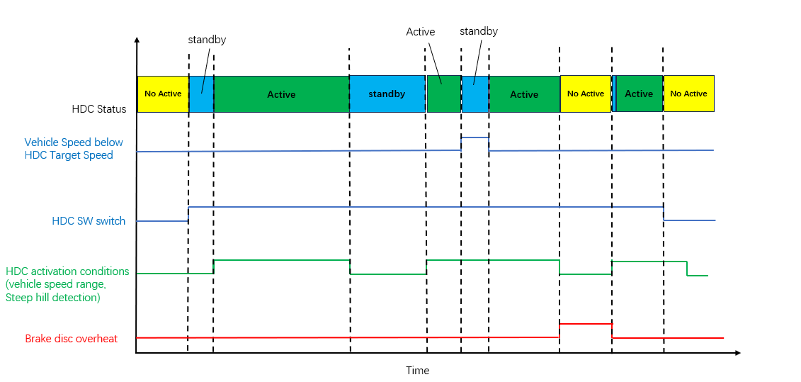
Figure 6. HDC Schematic Diagram Of The Work

Logical signals of function
The conditions of HDC enable and activation should meet the following conditions:
- The enable conditions of HDC function:
- The feature is not degraded by fault
And
- Driver activate HDC SW switch
And
- The system state is in running
- The disable conditions of HDC function:
- The feature is degraded by fault
OR
- Driver deactivate HDC SW switch
OR
- The system state is in not running
OR
- Brake Disc Temperature > TBD7
OR
- Accelerator pedal > TBD8
OR
- Vehicle speed is higher than 60kph

- The activation conditions of HDC function:
- Vehicle speed is lower than 35kph
And
- Hill Slope > 4%
And
- The vehicle speed is higher than HDC target speed
And
- The vehicle not in P gear position
And
- Brake Disc temperature < TBD1
And
- Master Cylinder Pressure < TBD2
And
- Accelerator pedal < TBD3
- The deactivation conditions of HDC function:
- Vehicle speed is lower than TBD4 (stop)
OR
- Hill Slope < 4%
OR
- The vehicle speed is lower than HDC target speed
OR
- Master Cylinder Pressure > TBD5
OR
- Accelerator pedal > TBD6

Base Parameters of function
This table defines the required threshold parameters in the function logics. These are all base values
for a specific platform or vehicle. The thresholds are available to be tuned and verified on the test
vehicles during development.
Conditions |  | Threshold | Remark
Activation Condition | Vehicle Speed | < 35 (kph) | Tunable
 | Hill Slope | > 4 (%) | Tunable
 | Brake Disc Temp | < TBD1 (℃) | Tunable
 | Master Cylinder Pressure | < TBD2 (Bar) | Tunable
 | Accelerator Pedal | < TBD3 (%) | Tunable
Deactivation Condition | Vehicle Speed | < TBD4 (kph) | Tunable
 | Hill Slope | < 4 (%) | Tunable
 | Master Cylinder Pressure | > TBD5 (Bar) | Tunable
 | Accelerator Pedal | > TBD6 (%) | Tunable
Disable condition | Brake Disc Temp | > TBD7 (℃) | Tunable
 | Accelerator Pedal | > TBD6 (%) | Tunable
 | Vehicle Speed | > 60 (kph) | Tunable

For a best performance expectation, the software is also required to support other variables change
Interface.

State interpretation and diagram
Several state groups are defined in HDC control, including the following main groups:
- Not Active
- standby
- Active
The picture shows the HDC subsystem work flow diagram.
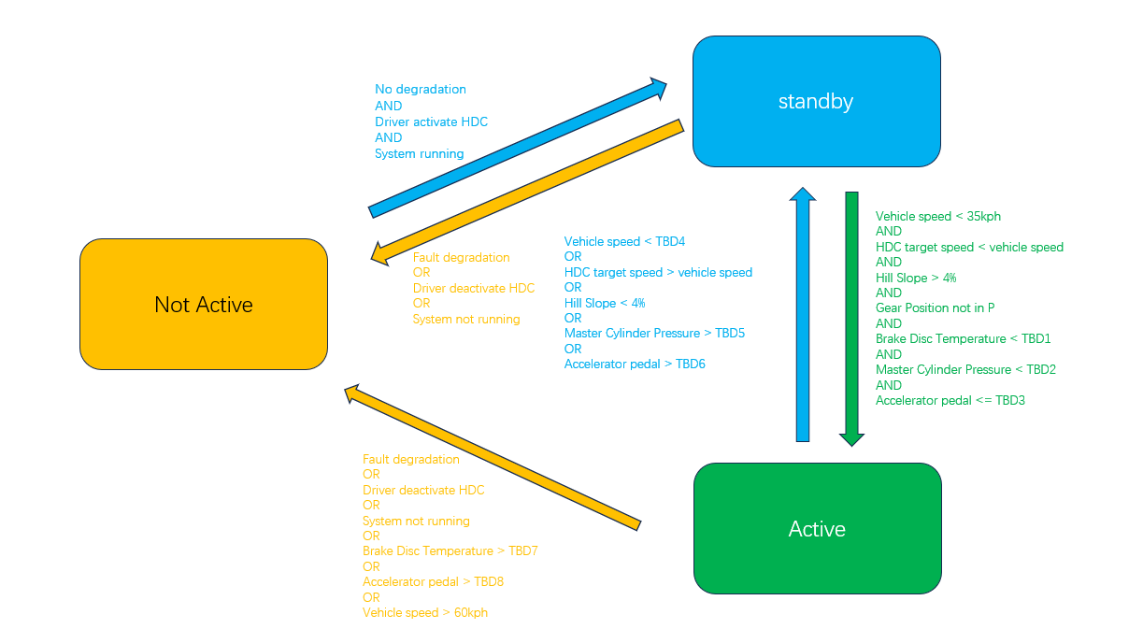

Diagnostic requirements
When there is a system malfunction that affects the ability for HDC to run normal control, then the fault manager will request that HDC enter a special control mode.

Special Control Modes
- CM_LC_HDC_NORMAL
- CM_LC_HDC_INHIBIT

Partial System Shutdown Modes
If a failure occurs while HDC is already active then will enter a Partial System Shutdown (PSSD) mode. It depends on the particular fault and the current status of the control, but a given channel could be requested to run one of the following modes:
- PSSD_LC_HDC_NORMAL
- PSSD_LC_HDC_RAMP_DWN_SLW

Major Additional Function
NA

Special States Detect
NA

Functional safety

Hazard and Risk analysis
This part will be detailed in HARA. Refer to the HARA documents provided by VW.

Functional safety concept
This part will be detailed in FSC. Refer to the FSC documents provided by VW.

Degradation Mode
Refer to the failsafe manual, which defines details and cases. The failsafe manual should be updated during each software release

Regulatory Requirements
NA

Function Dependencies
External systems | Description | Responsible
LDCU | Vehicle Info | LDCU
IMU | Acceleration and Yaw Single | EK
EPS | Steering ability | EF
Foundation Braking | Calipers, discs, tubing | EF

Internal

Arbitration of HDC and ADAS
HDC has higher priority than ADAS deceleration control.
In the case of HDC Active, ADAS cannot be active, via interface of IPB_CruiseCtrlCancelReq;
In the case of ADAS Active, HDC switch can be turn on and HDC enter standby status, if HDC
activation condition fulfilled HDC Active, then ADAS shall be disable via interface of
IPB_CruiseCtrlCancelReq;

Extra

HDC Switch：
HDC function can be switched off and on via the virtual switch on the screen by the driver. The
request signal transmit to iBRS from the CDCU.

8.2.1 Self-checking strategy
After KL15 on, the system will send the default value until self check complete. The HMI will illuminate
the HDC lamp and keep on 3s.

8.2.2 Function Active Display Strategy
The HMI strategy when HDC function active：
Name | Symbol | KL15 Status | HMI Strategy
HDC  Active |  | ON | 仪表显示策略：  1. 仪表如果收到 IPB_HDCActiveSt = 0x0:NotActive / 0x1：standby / 0x3:reserved 且  IPB_HDCFault = 0x0:Notfault，不点亮指示灯；  2. 仪表如果收到IPB_HDCActiveSt==Standby且IPB_HDCFault==Notfault，点亮灰色指  示灯；  3. 仪表如果收到 IPB_HDCActiveSt = 0x2:Active 且 IPB_HDCFault = 0x0:Not fault，点亮  绿色指示灯，并弹出文字提示“陡坡缓降功能已激活”，3s 后文字消失（无论是否有  效）。直到下一次检测到IPB_HDCActiveSt 从其他状态变为0x2:Active 且  IPB_HDCFault = 0x0： Not fault；  异常处理：  如果收不到 IPB_HDCActiveSt 或 IPB_HDCFault 信号 1s 按通用策略 10 帧认为丢失，点亮黄色指示灯。  备注：  N/A
When the HDC activate, need to illuminate the brake lamp.

8.2.3 Fault Display Strategy
Name | Symbol | KL15 Status | HMI Strategy
HDC Fault |  | ON | 仪表显示策略：  仪表如果收到 IPB_HDCFault = 0x1:Fault，点亮黄色指示；  大屏显示策略：  大屏收到HDC故障信号：IPB_HDCFault=0x1:Fault，大屏显示文字标题：“陡坡缓降功能不可用” 文  字内容“陡坡缓降功能不可用，无法辅助车辆保持匀速下坡”  异常处理：  如果收不到 IPB_HDCActiveSt 或 IPB_HDCFault 信号 1s 按通用策略 10 帧认为丢失，点亮黄色指示灯。  备注：  NA

Special Performance Requirements
NA.

Appendix A

Change History
Version | Change Content | Date（D/M/Y） | Reviewer
V1.0 | Initial edition | 7/07/2025 | Chen Haiyan

